Computer Language Coding Concepts

Event Interface Reference
An event command will always implement an interface specified by the Event object. But if you want to express a command’s implementing the event interface without actually being tied to the event, it would look like this:

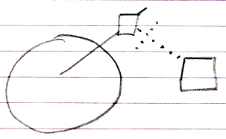

So the event connector is there and the command’s interface reference is tied to the event connector.

Author & Copyright: Jan-Joost van Zon Date: May 10, 2010 – May 14, 2010 Location: Oosterhout, The Netherlands Status: Finished

